# **Scenario 1:**

Procedure Creation:

CREATE OR REPLACE PROCEDURE ProcessMonthlyInterest IS

BEGIN

FOR acc IN (SELECT AccountID, Balance FROM Accounts WHERE AccountType = 'Savings') LOOP

UPDATE Accounts

SET Balance = acc.Balance * 1.01,

LastModified = SYSDATE

WHERE AccountID = acc.AccountID;

END LOOP;

COMMIT;

END;

/

Checking Before Update;

SELECT AccountID, AccountType, Balance FROM Accounts WHERE AccountType = 'Savings';

Executing Procedure:

BEGIN

ProcessMonthlyInterest;

END;

/

Checking After Update:

SELECT AccountID, AccountType, Balance FROM Accounts WHERE AccountType = 'Savings';

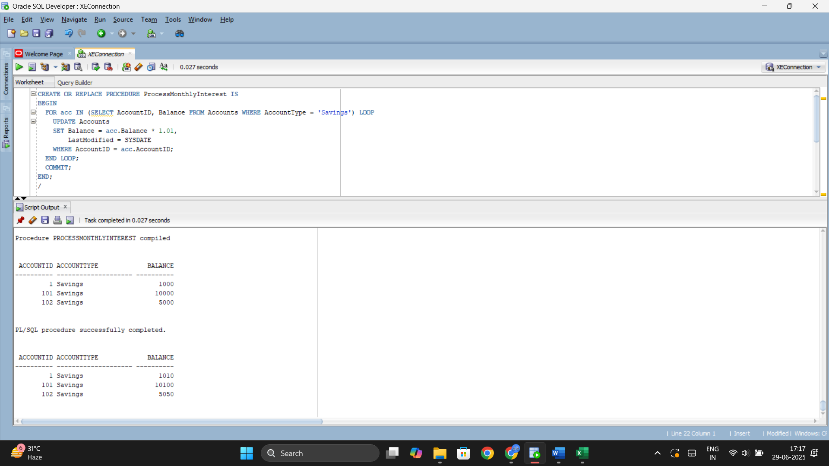

# **Scenario 2:**

Procedure Creation:

CREATE OR REPLACE PROCEDURE UpdateEmployeeBonus (

p_Department IN VARCHAR2,

p_BonusPercentage IN NUMBER

) IS

BEGIN

UPDATE Employees

SET Salary = Salary + (Salary * p_BonusPercentage / 100)

WHERE Department = p_Department;

COMMIT;

END;

/

Checking Before Update;

SELECT EmployeeID, Name, Department, Salary FROM Employees WHERE Department = 'IT';

Executing Procedure:

BEGIN

UpdateEmployeeBonus('IT', 10);

END;

/

Checking After Update:

SELECT EmployeeID, Name, Department, Salary FROM Employees WHERE Department = 'IT';

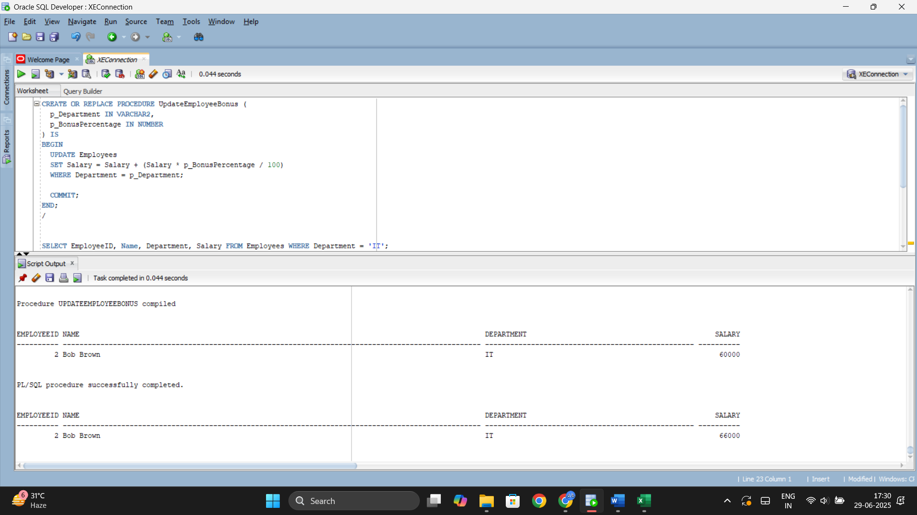

# **Scenario 3:**

Procedure Creation:

CREATE OR REPLACE PROCEDURE TransferFunds (

p_FromAccountID IN NUMBER,

p_ToAccountID IN NUMBER,

p_Amount IN NUMBER

) IS

v_Balance NUMBER;

BEGIN

SELECT Balance INTO v_Balance

FROM Accounts

WHERE AccountID = p_FromAccountID

FOR UPDATE;

IF v_Balance < p_Amount THEN

RAISE_APPLICATION_ERROR(-20001, 'Insufficient funds in source account.');

END IF;

UPDATE Accounts

SET Balance = Balance - p_Amount,

LastModified = SYSDATE

WHERE AccountID = p_FromAccountID;

UPDATE Accounts

SET Balance = Balance + p_Amount,

LastModified = SYSDATE

WHERE AccountID = p_ToAccountID;

COMMIT;

END;

/

Checking Before Update;

SELECT AccountID, Balance FROM Accounts WHERE AccountID IN (103, 104);

Executing Procedure:

BEGIN

TransferFunds(103, 104, 1000);

END;

/

Checking After Update:

SELECT AccountID, Balance FROM Accounts WHERE AccountID IN (103, 104);

